### Dreaming of Spring Flowers - An Amaryllis Torus

I am tired of winter with all of the snow that we had this season and I want spring to begin. I am dreaming of warm weather with beautiful flowers. Here is a beautiful flower of my dreams...an amaryllis torus flower. I love the way that this torus swirls around in the center. From afar, I think that this paper amaryllis fools the eye and looks real.

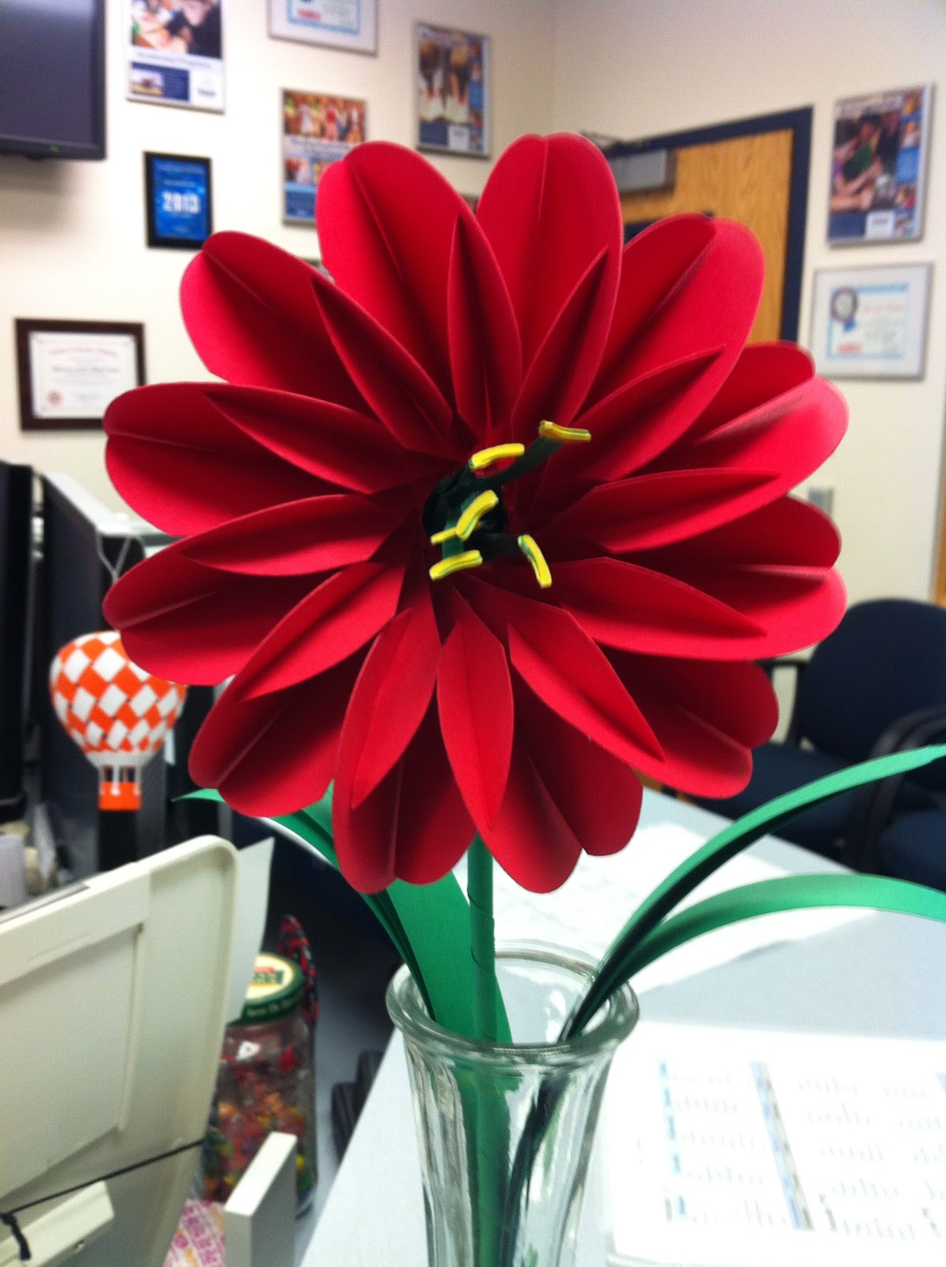

Amaryllis Torus Flower

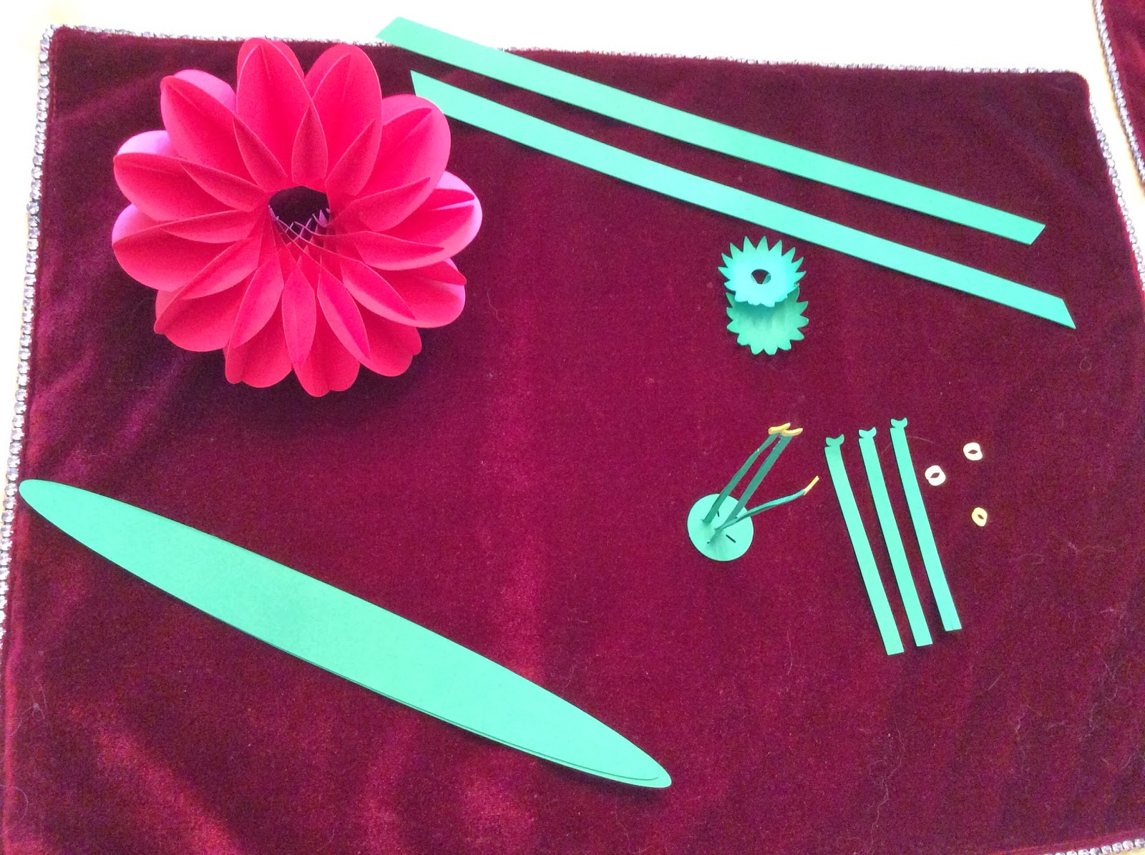

Flower is completed. Ready to make the stem.

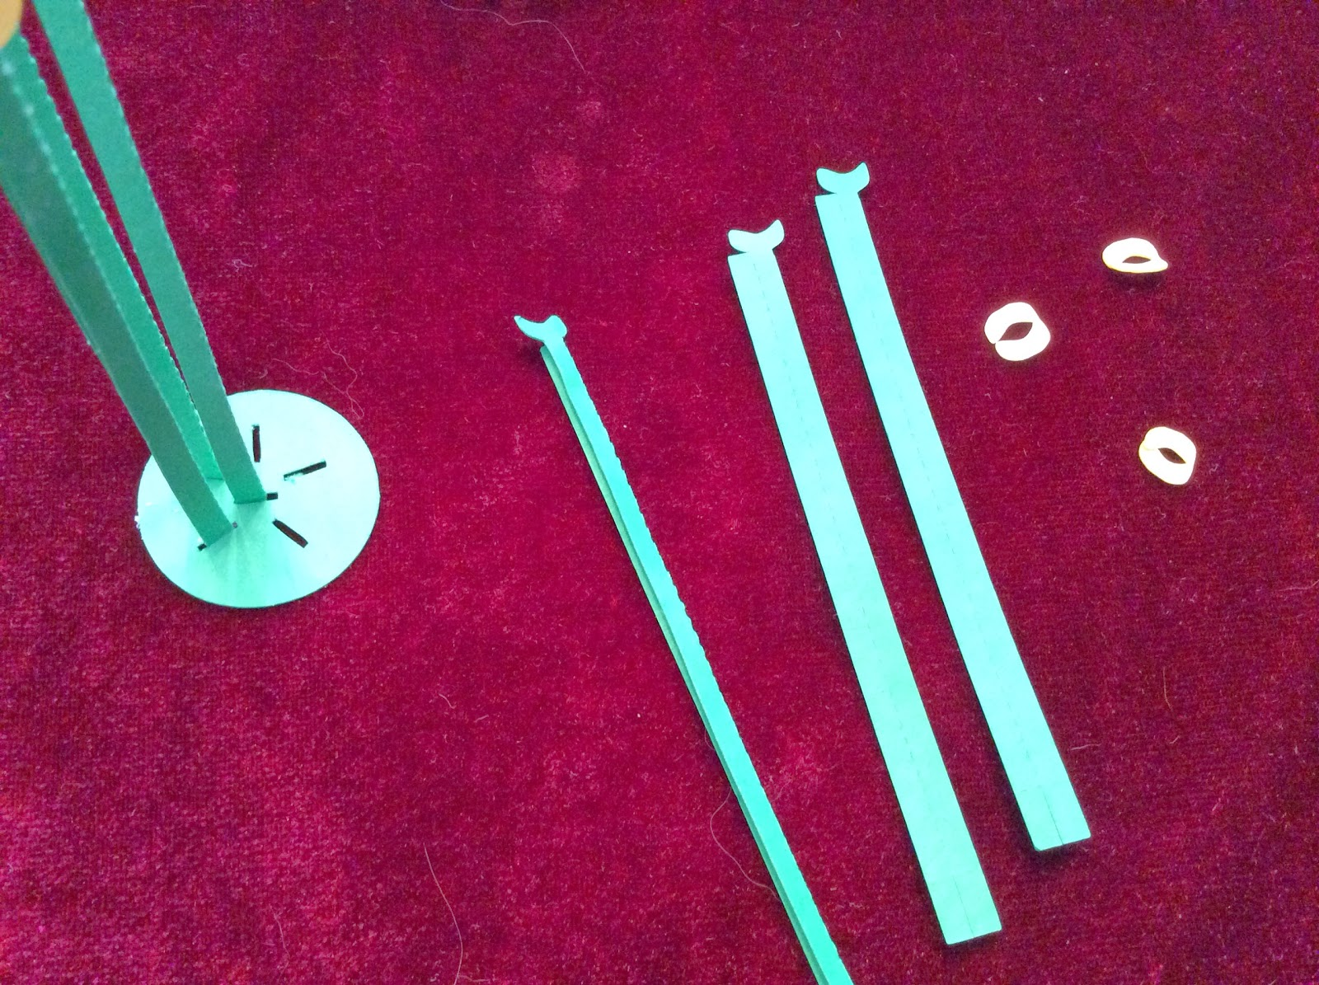

Make the Stamen and the Filaments

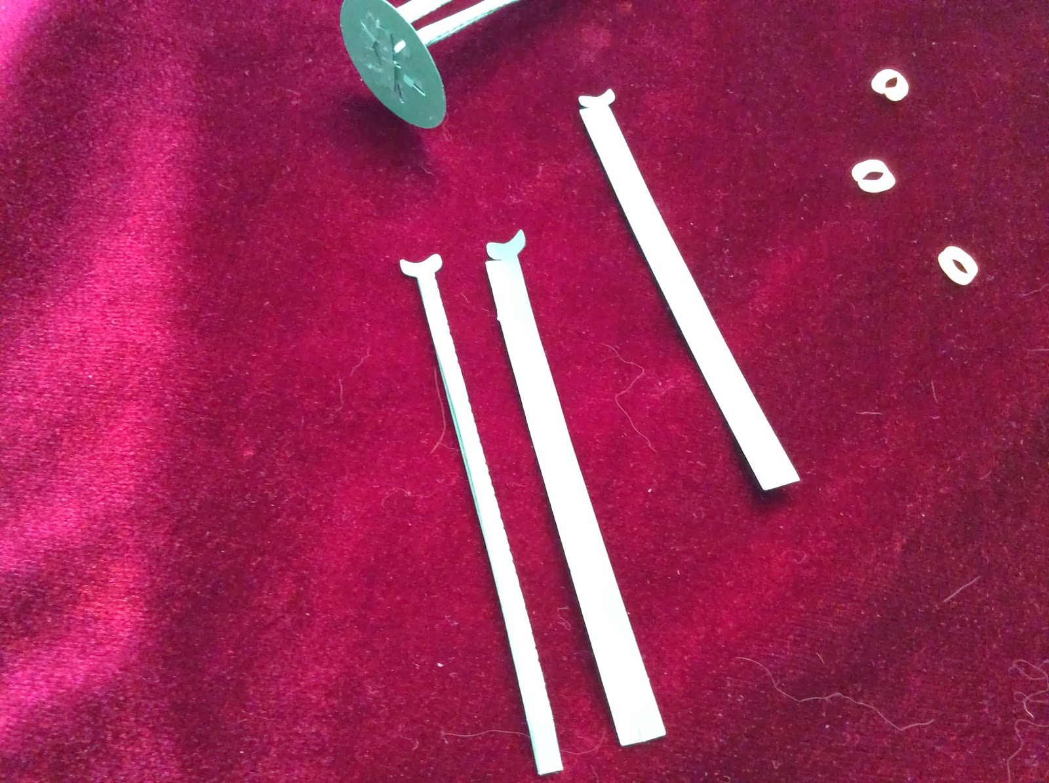

Glue a contrasting-colored stamen and fold the filament in half as shown.

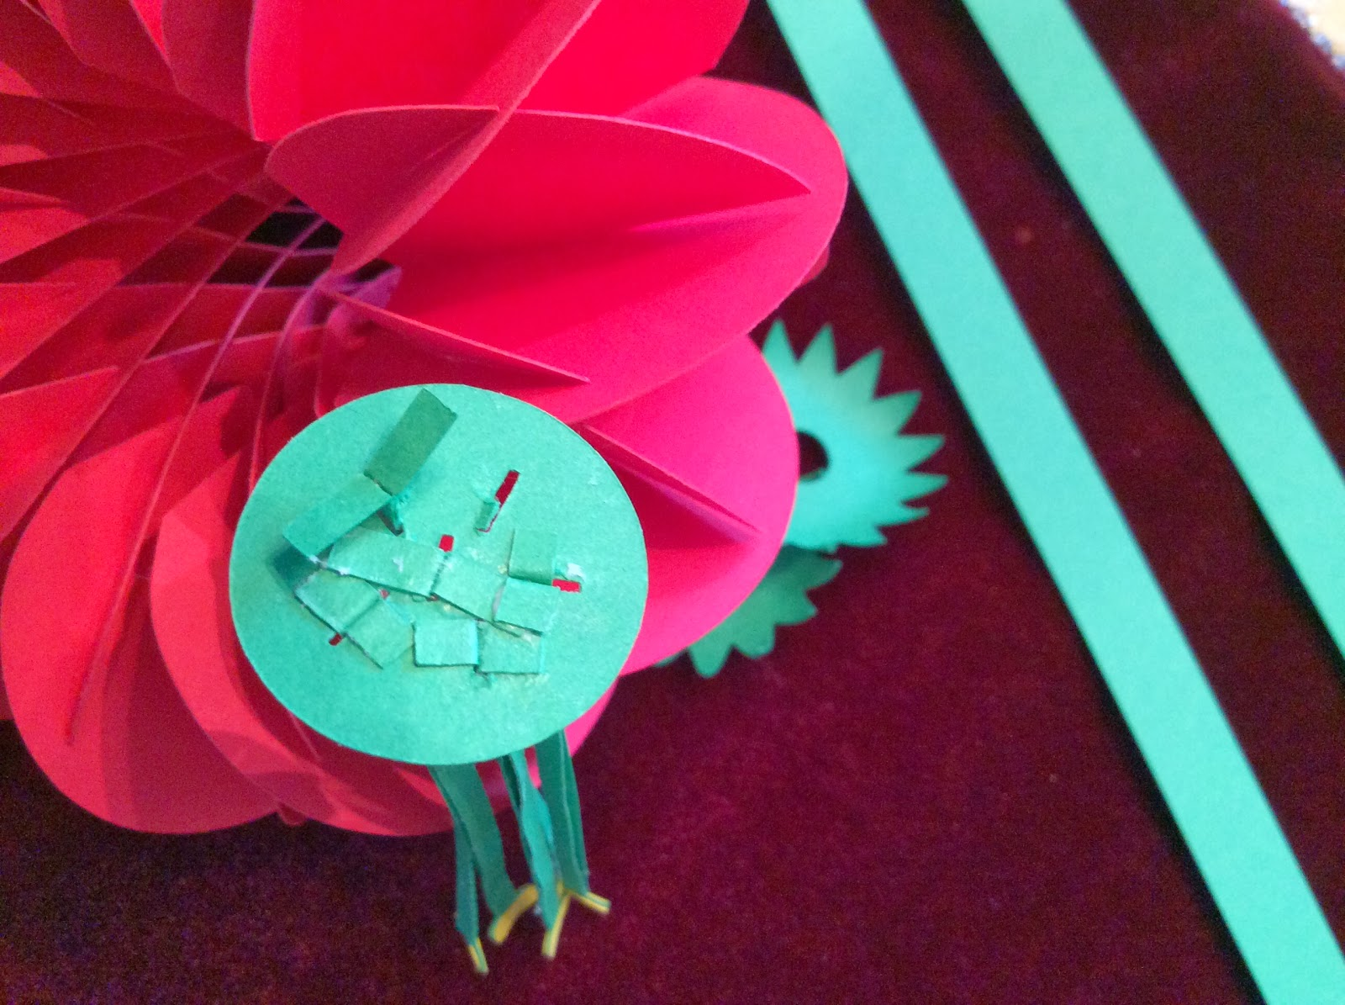

Glue the filament to the bottom of the circle as shown.

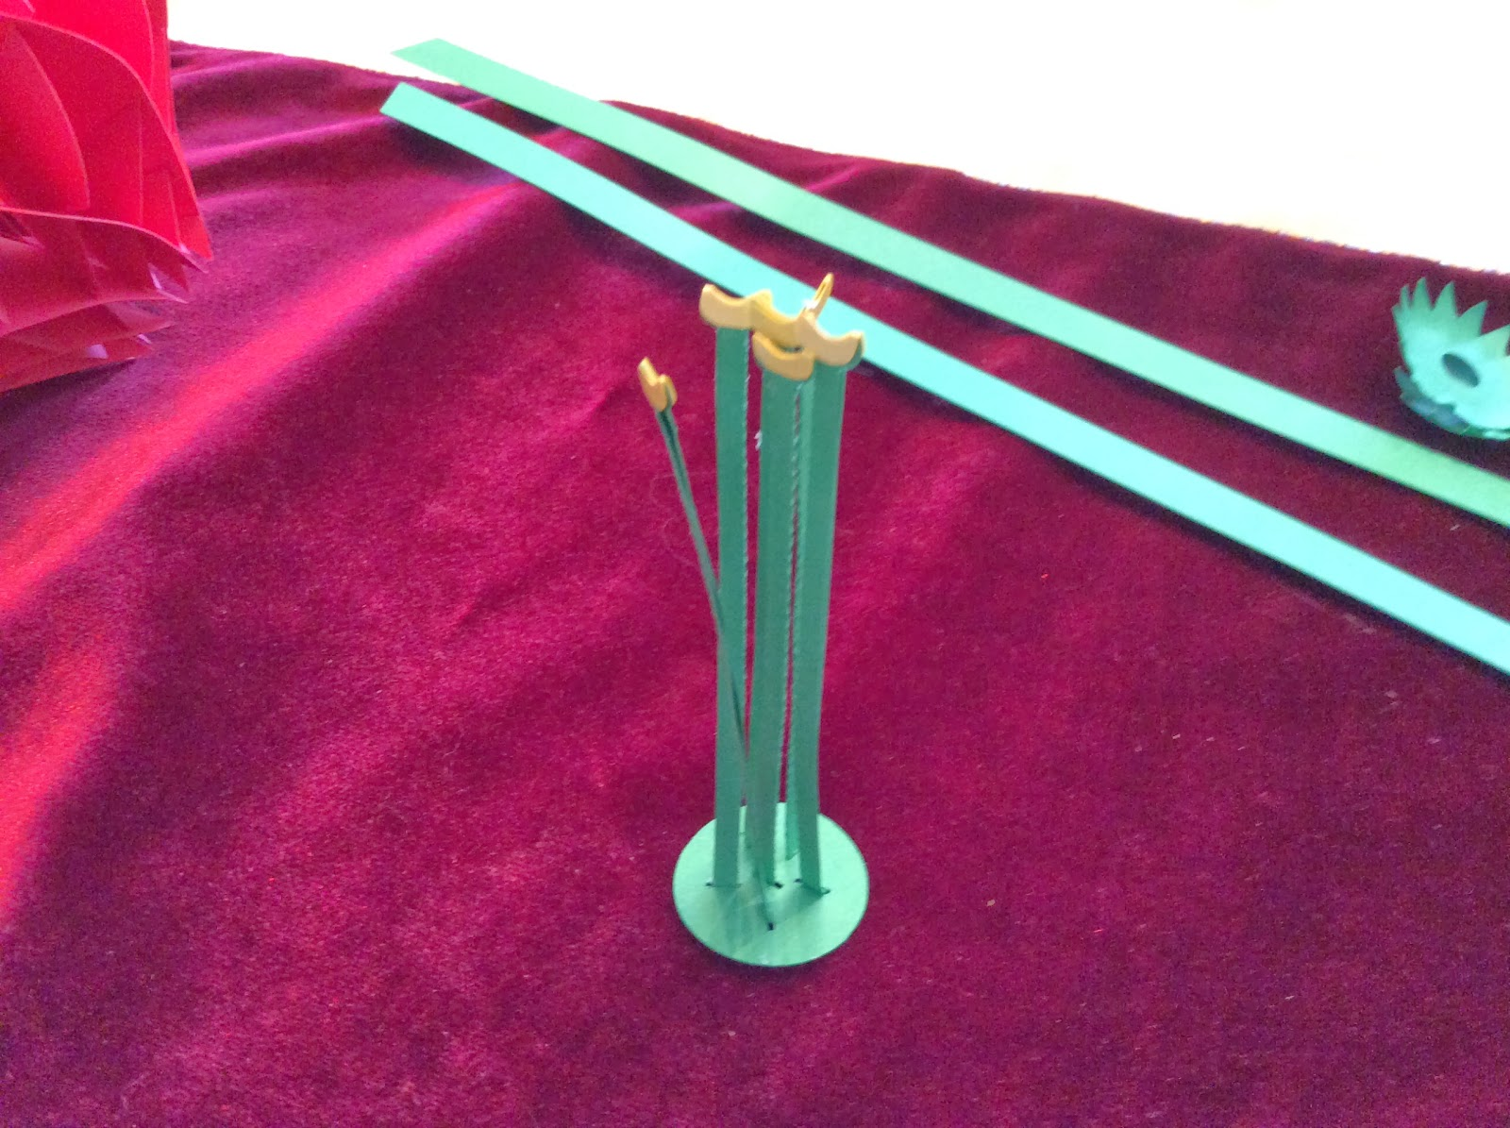

Completed Filaments

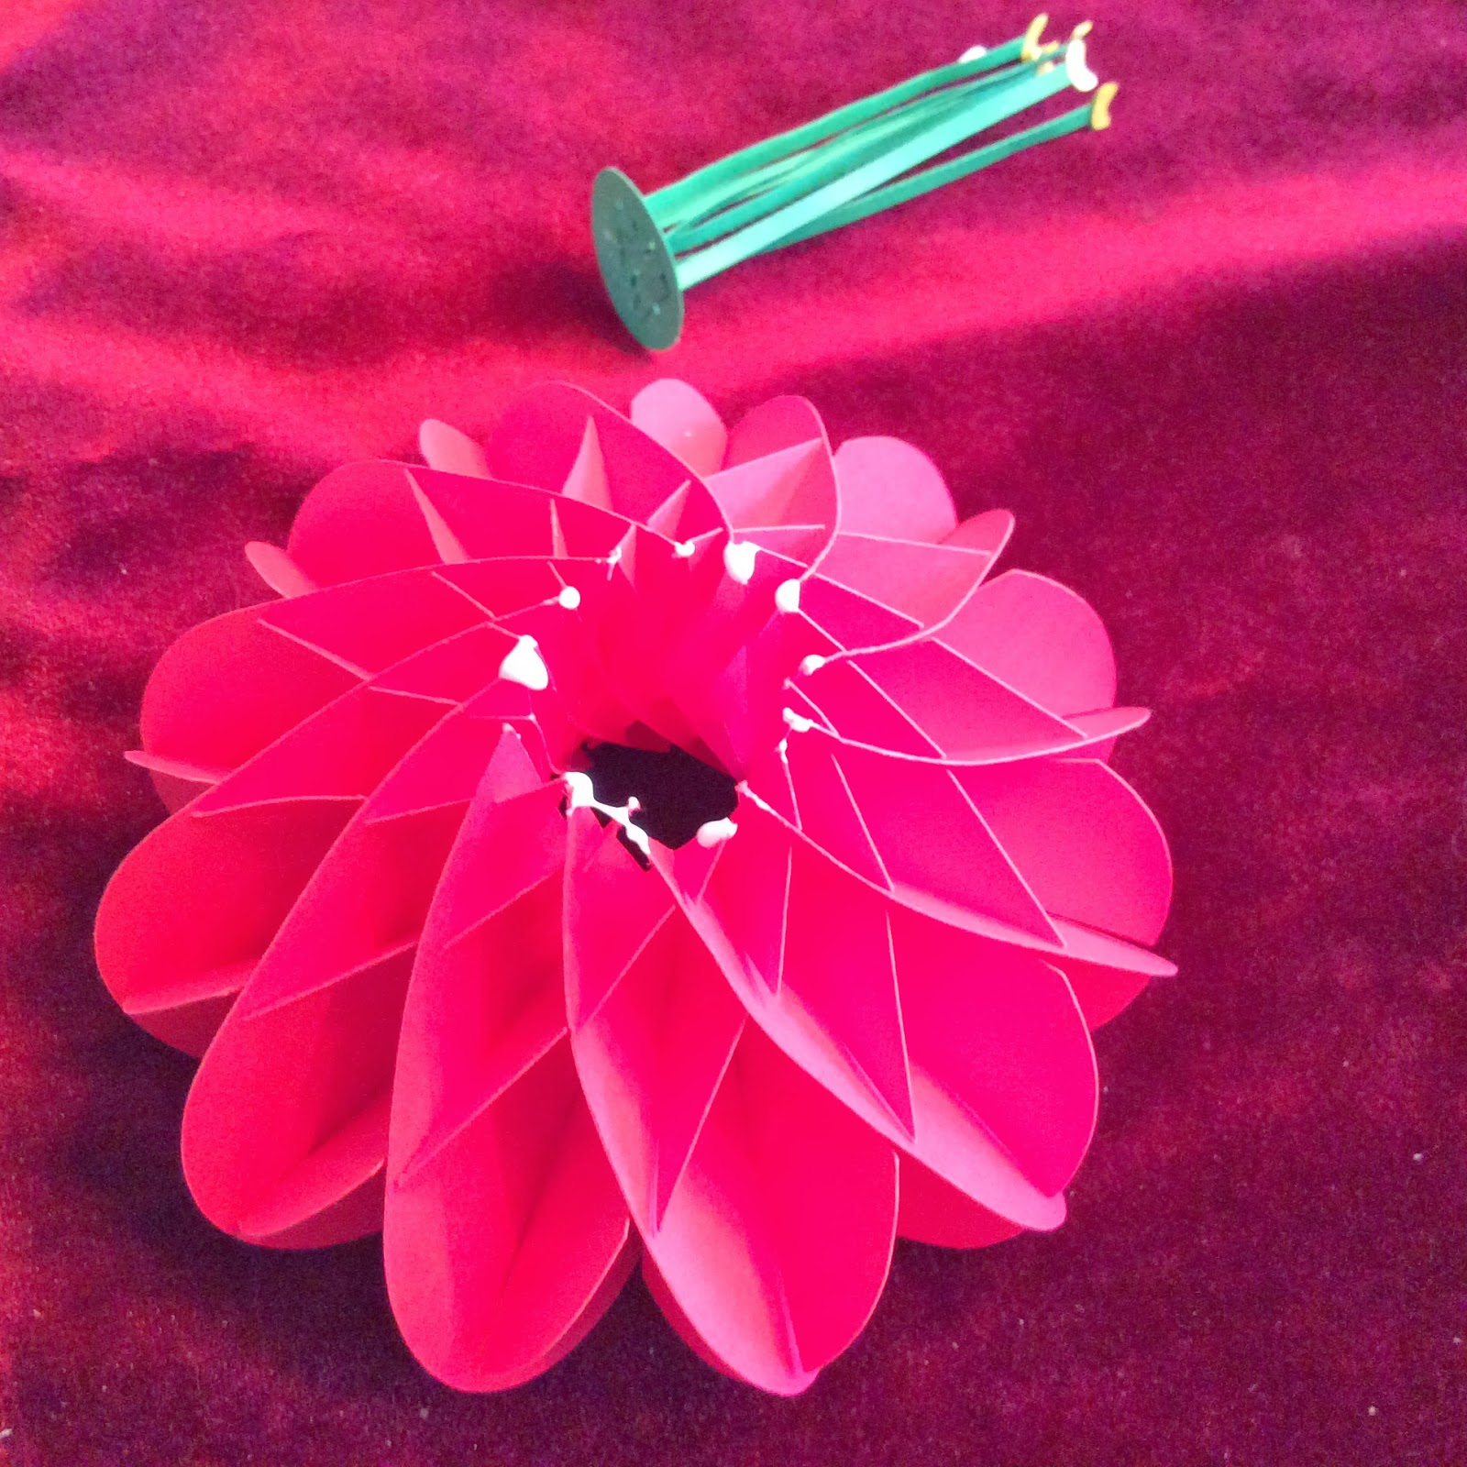

Apply glue to the back of the flower.

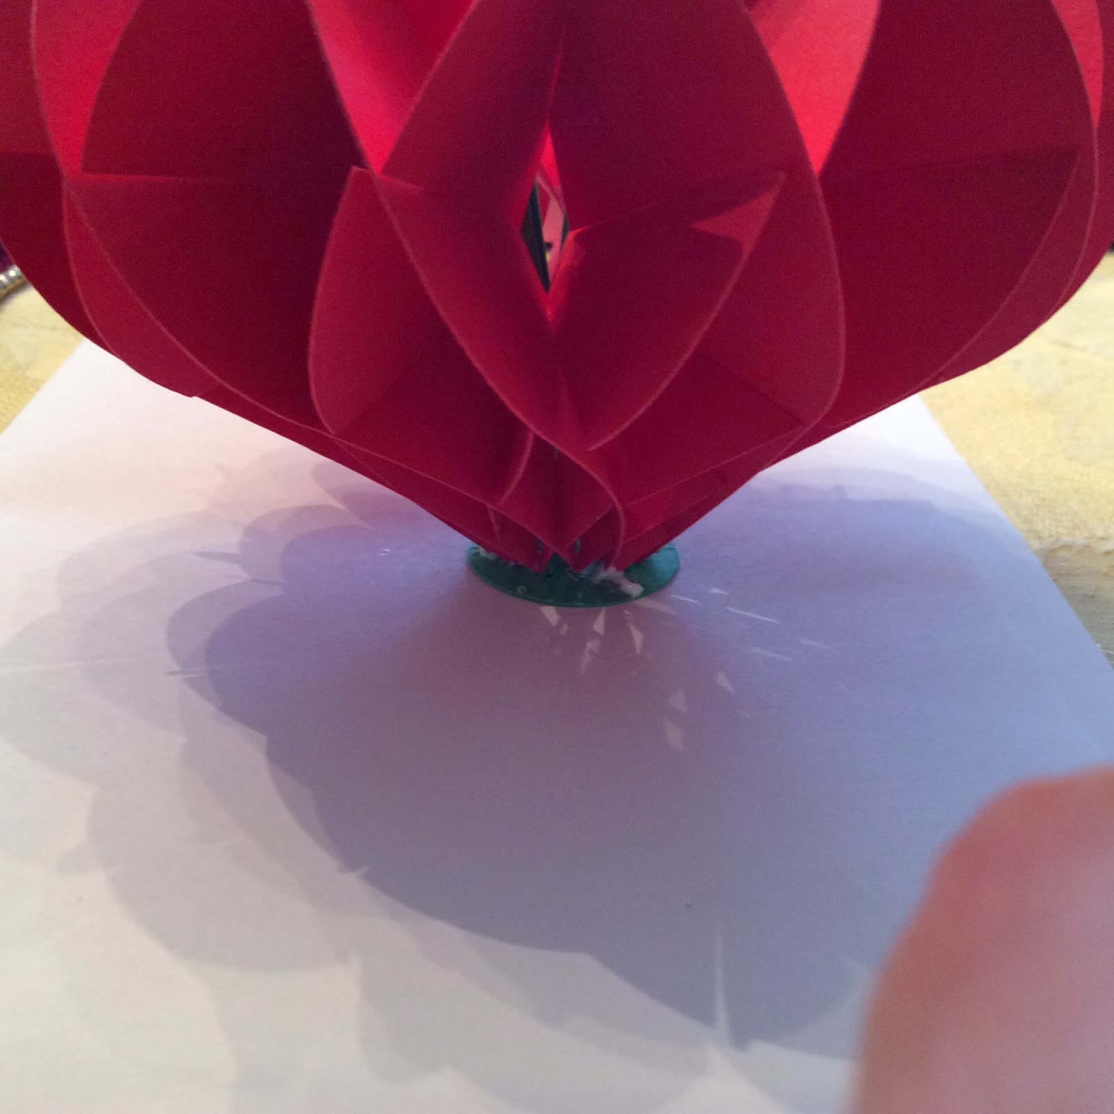

Insert the Filaments to the center and make sure that the glue adheres evenly across the back of the flower.

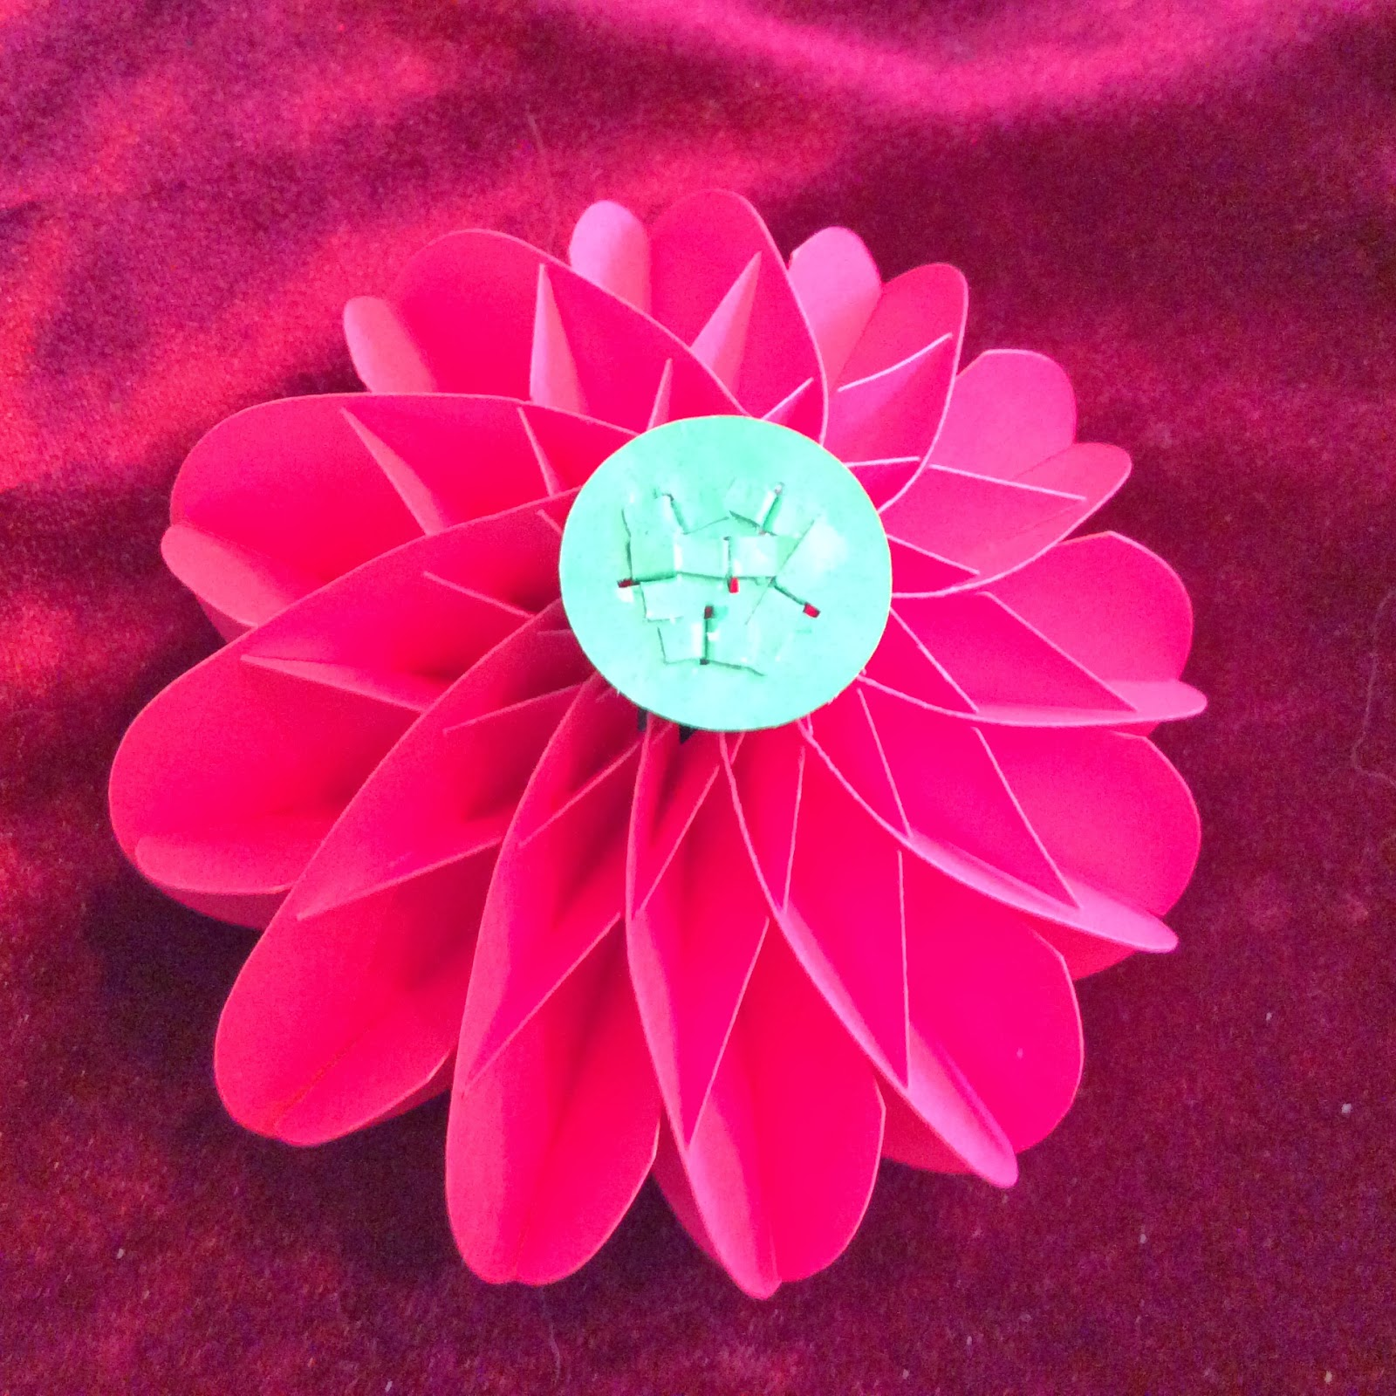

Here is what the back of the flower looks like after it has been glued.

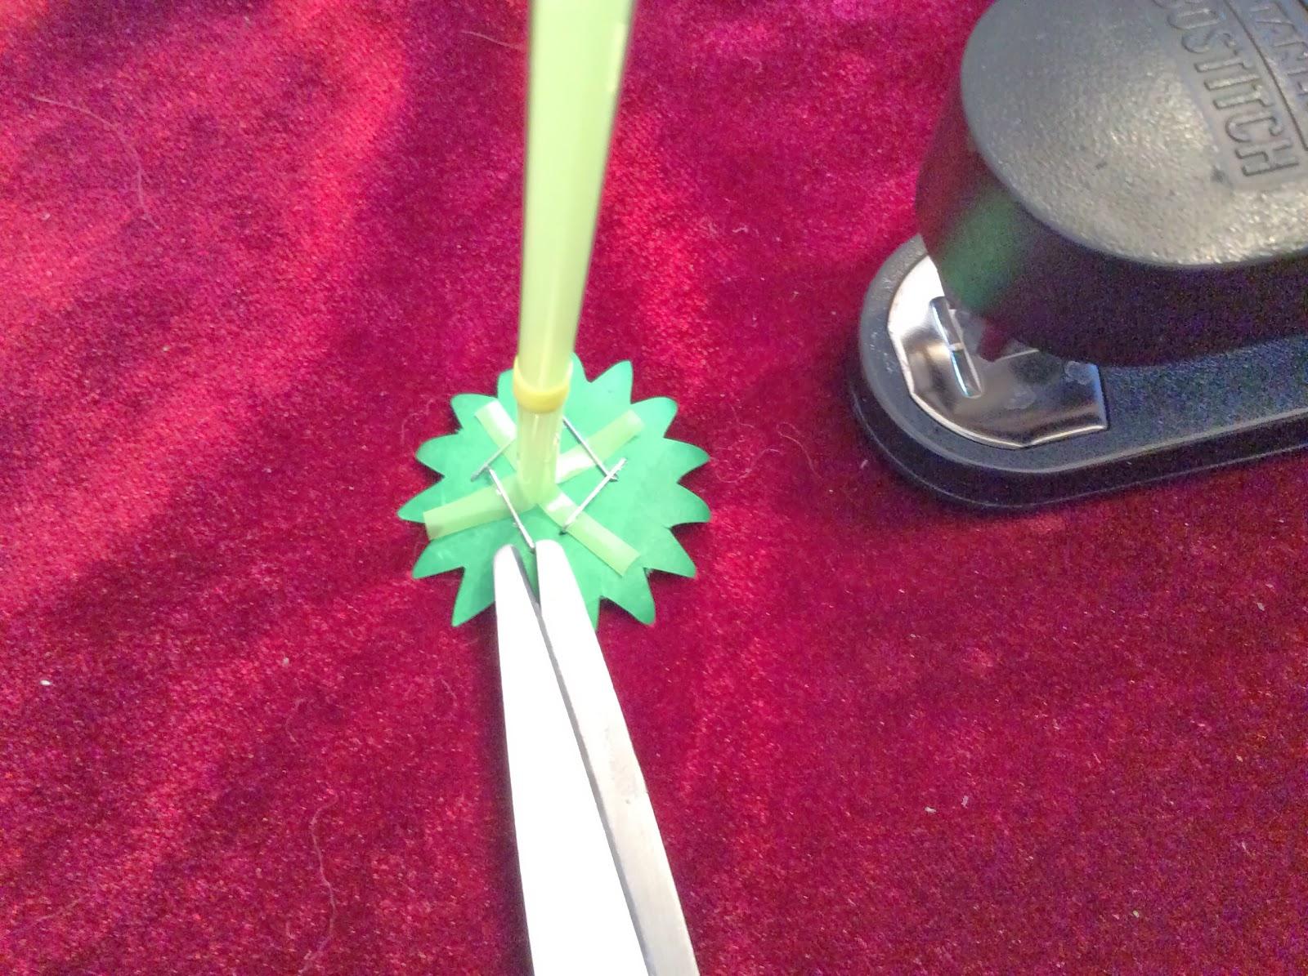

Cut the end of a straw into four sections as shown in the above picture. Staple to the sepal (zigzag edged circle without the whole in the middle)

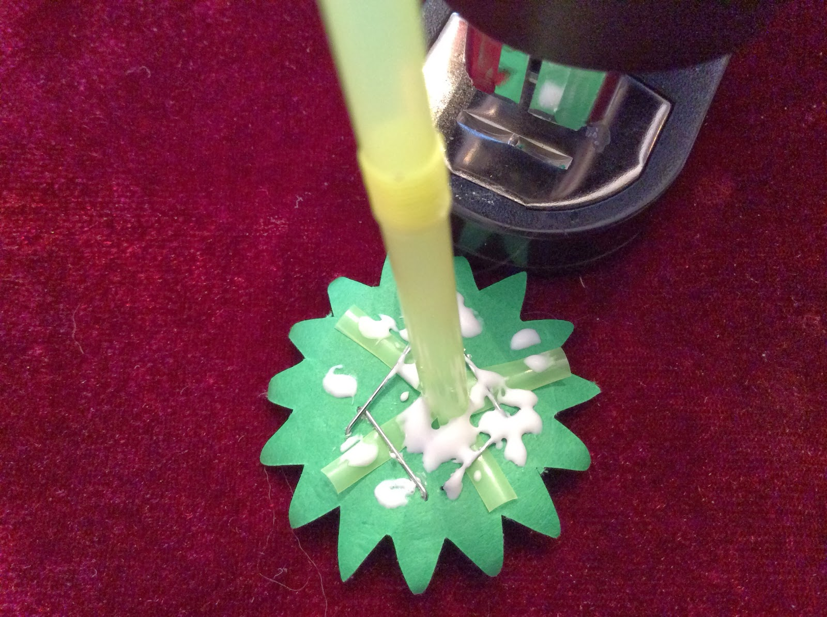

Apply glue as shown and add the sepal (the zigzag circle with the whole in the middle) to the center of the straw. I used two straws for the stem. I pushed one straw into the other to make one long stem.

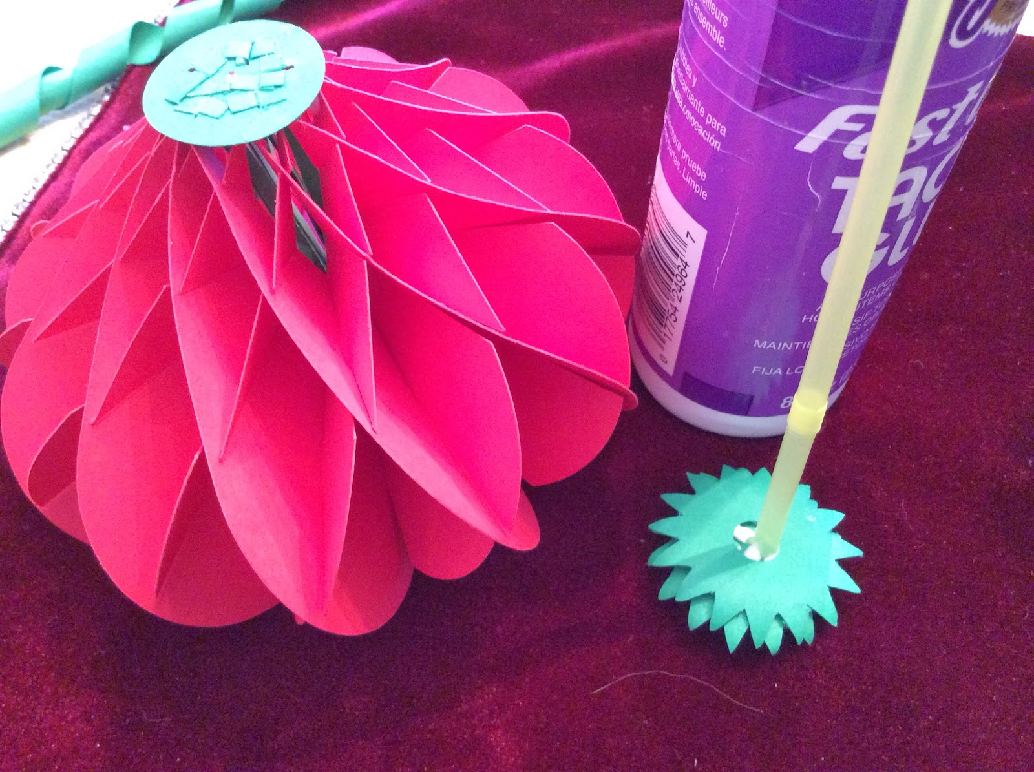

Both sepals are in place on the straw.

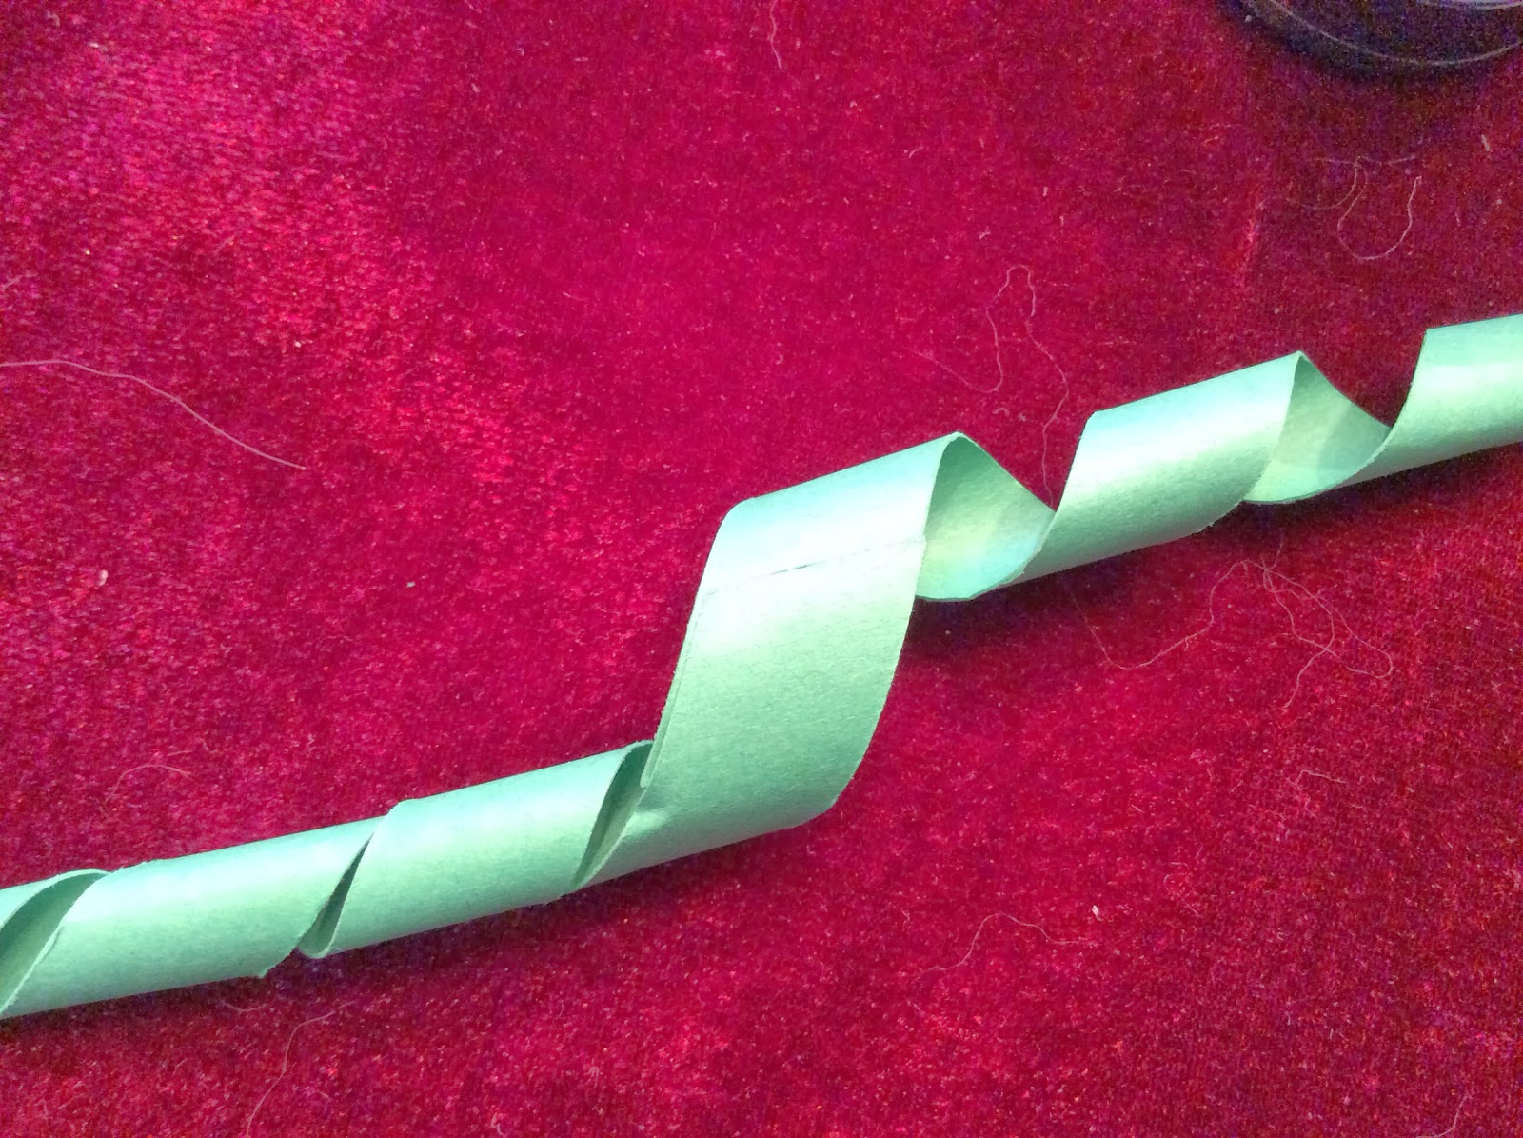

Curl the long strips of paper so that it will be easy to apply around the straw.

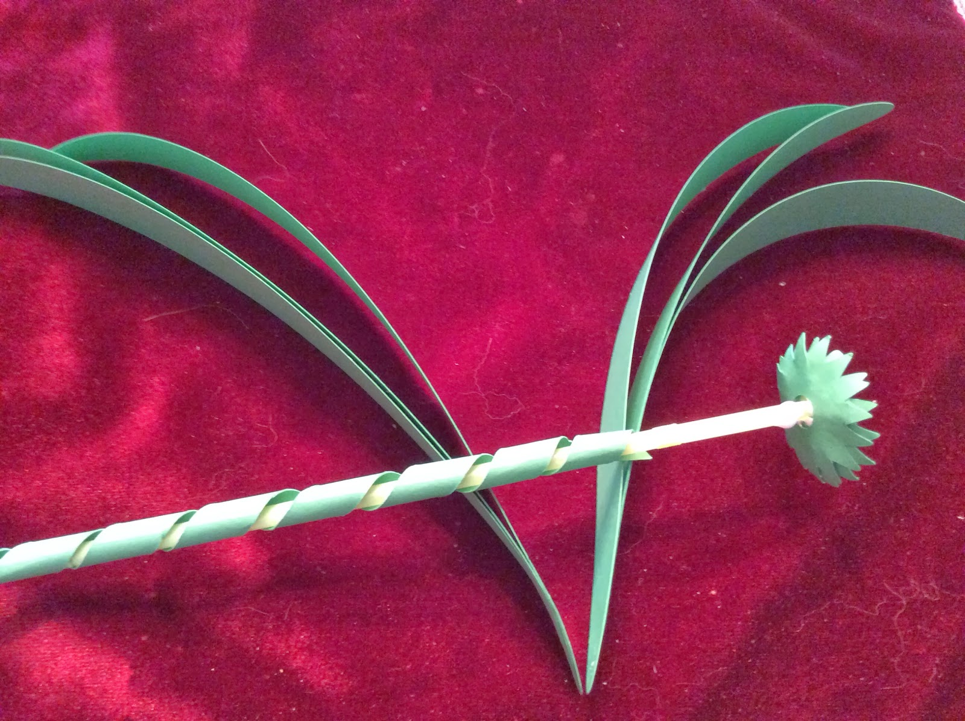

Glue the strip around the straw. Curl the leaves as shown.

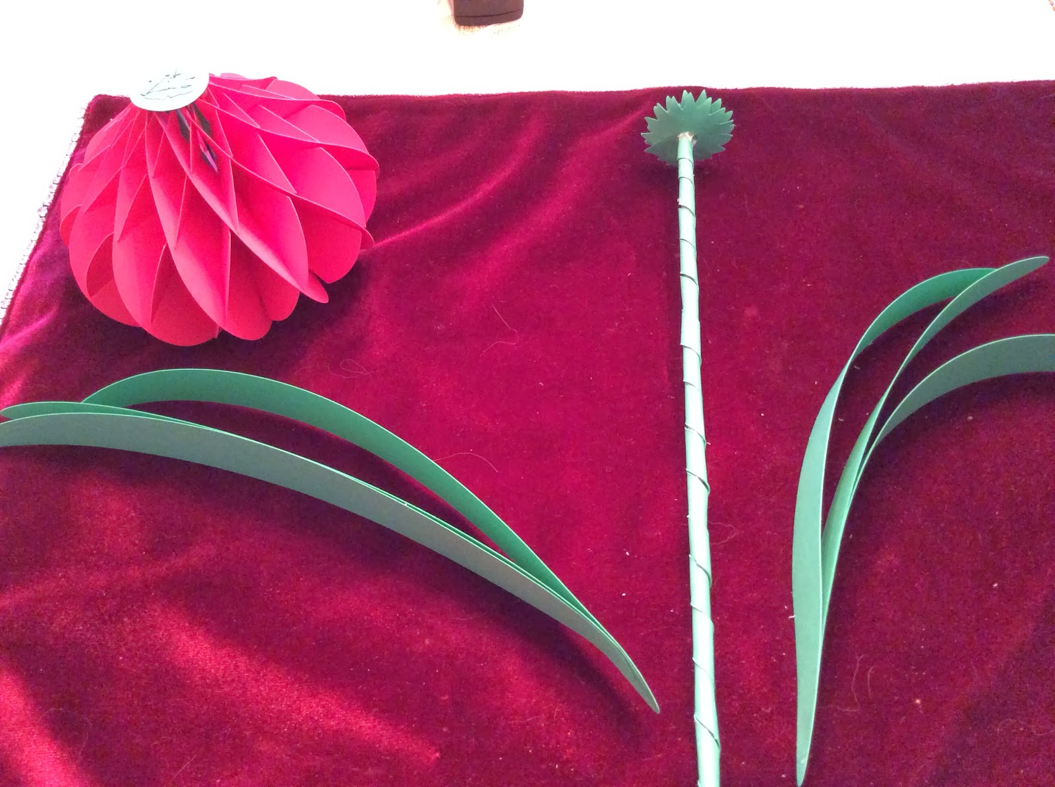

Glue the two sets of leaves.

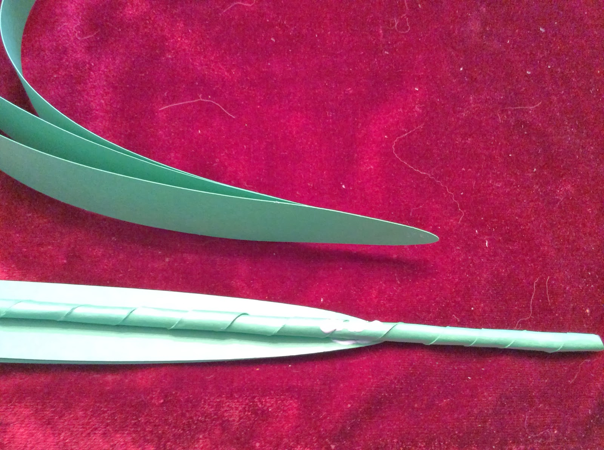

Attach the leaves with glue and wrap another strip of paper around the stem.

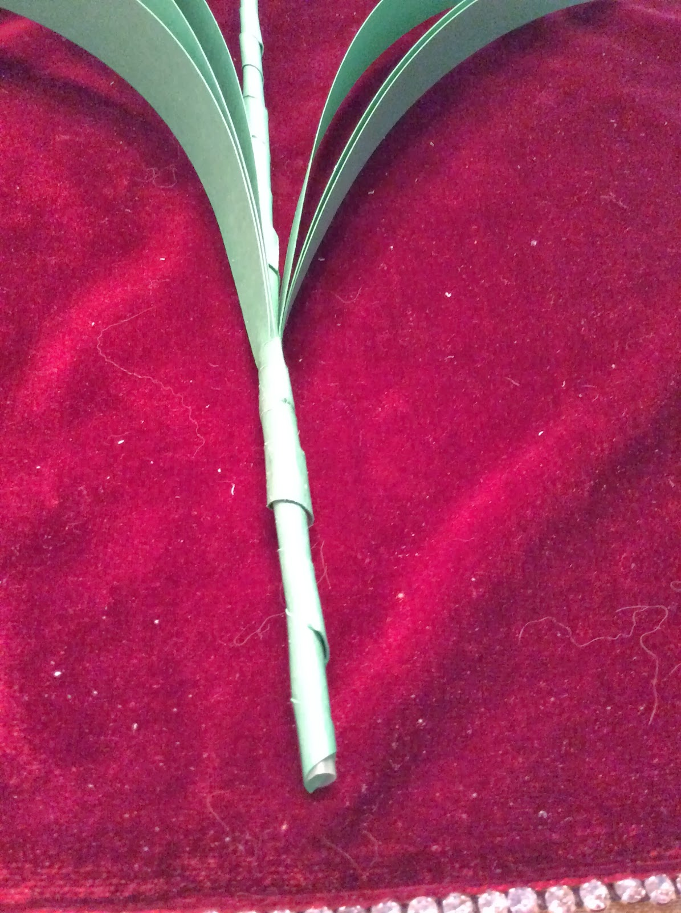

Here is what the leaves look like when attached.

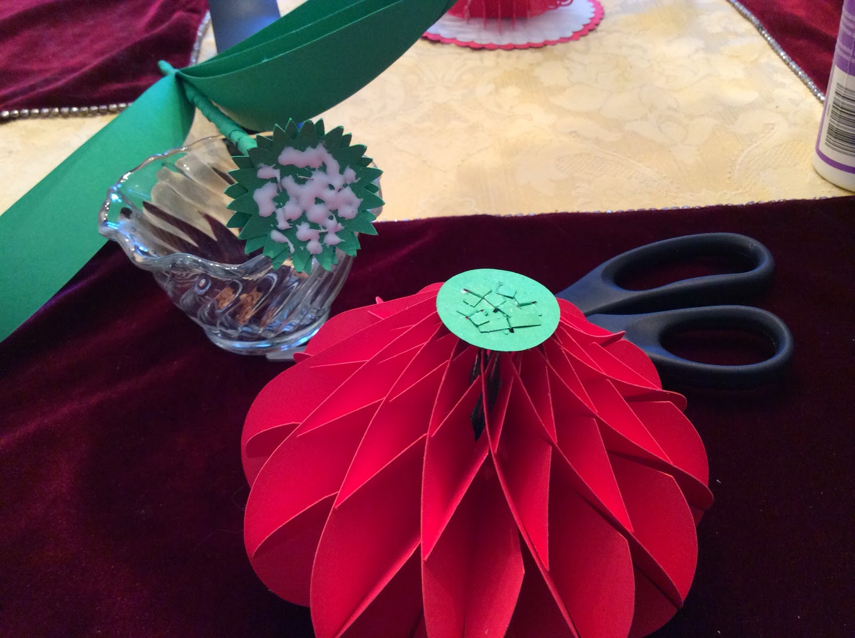

Use a lot of glue to attach the flower head to the stem.

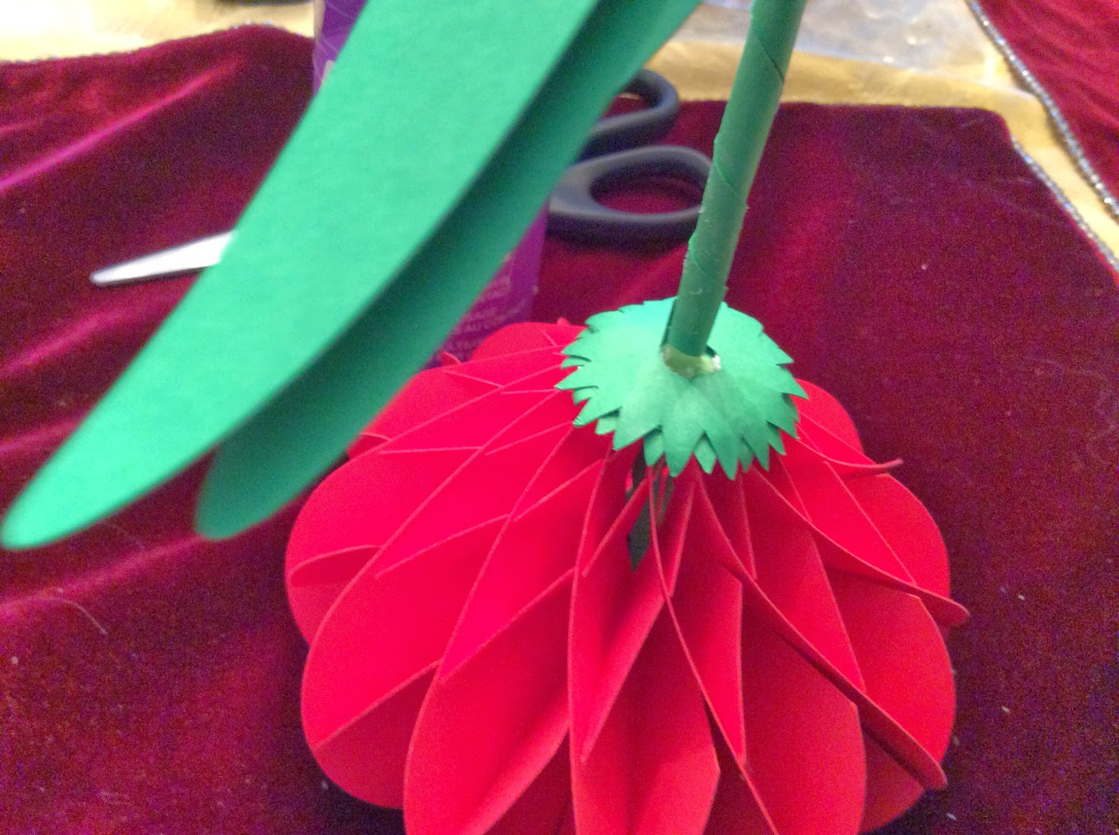

Do not move the flower until the glue is fully dry. I inserted a wooden skewer into the middle of the straw to give the stem some strength. Otherwise, the weight of the flower will bend the straw.

Dreaming of Spring...Enjoy the Amaryllis!